- Right-click Windows start icon from the left-bottom corner of the task bar
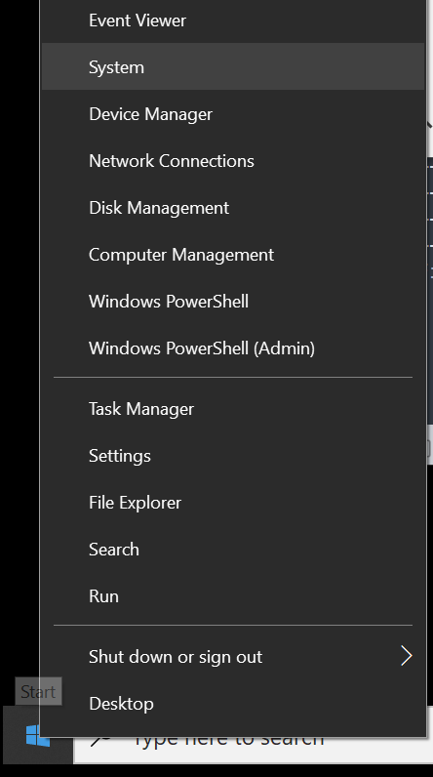

- Select “Advanced system settings”

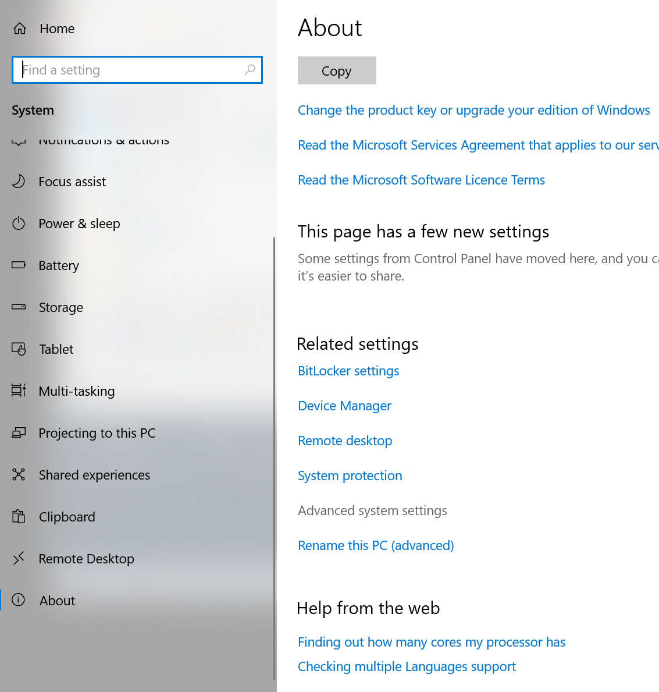

- Click the “Environment Variables” button

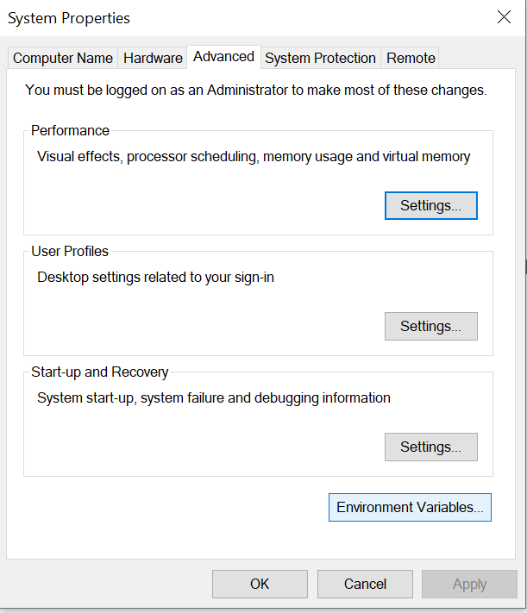

- Under System variables, select “Path”, then click the Edit button
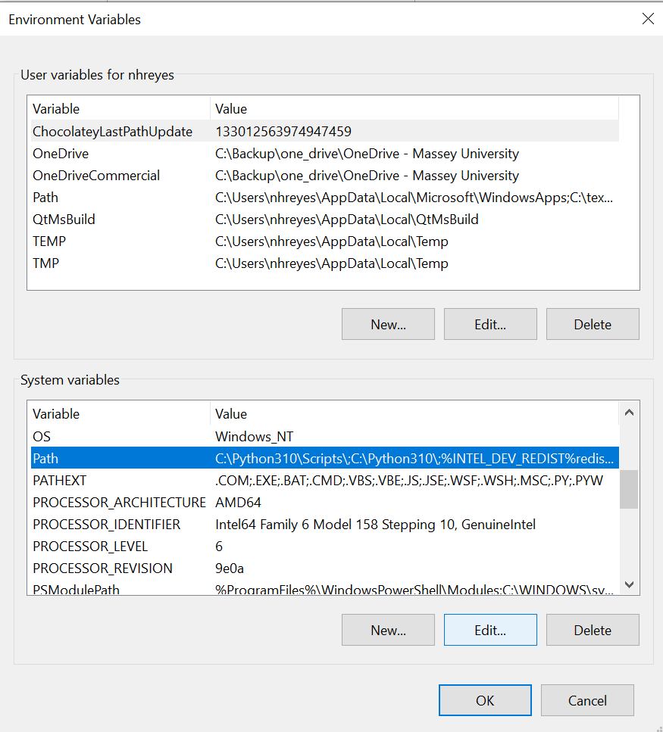

- Make an entry for your gcc installation (folder containing the binary files)
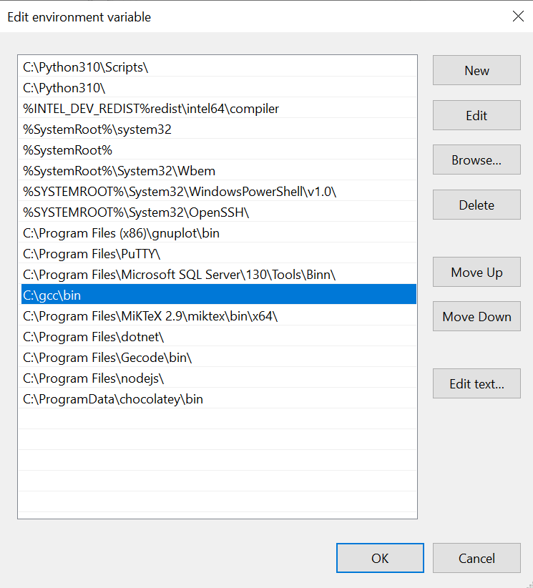

- Open a command prompt, then issue the following command to test if your gcc can be found
